GENERAL INFO
Transport Request # | DS4K905862
Short Description | CLR: ELT Latest Code Sync - 2
Owner of Transport Request | CLEAR TAX
Department | Accounts
Email ID
Issue Raised by | Prasad Ahale | Vivek Chopade
Voice Incident #
DESCRIPTION OF CHANGE
Description of changes captured and affected entities | The TR contains PAT file and the latest updates for the clear extraction program
VALIDATIONS IN TESTING SYSTEM
Testing performed in QS4? | YES ☒ NO ☐
Test Results status | PASS ☒ FAIL ☐
APPROVALS FOR IMPORT IN PRODUCTION
VEPL Core Team Member- Prasad Ahale | YES ☐ NO ☐
VEPL Process Owner – Prashant D. | YES ☐ NO ☐
Clear Tax Functional Lead – | YES ☒ NO ☐
Date of Import in Production

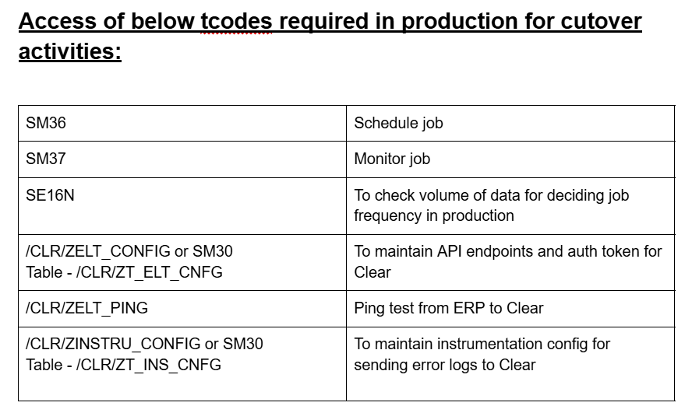

Unit testing:

- TR created in Dev system and moved to the QS4 system consisting of clear’s extraction programs.
- Endpoints maintained in Clear’s Custom tables /CLR/ZT_ELT_CNFG and /CLR/ZT_INS_CNFG to ensure connectivity between ERP and Clear’s portal.
- Extraction program /CLR/ZELT_EXEC_COMMAND scheduled as background job to extract data from ERP.

Expected Results:
After changes:
Ingestion job scheduled in QS4 server. (Job scheduled for extraction program /clr/zelt_exec_command)

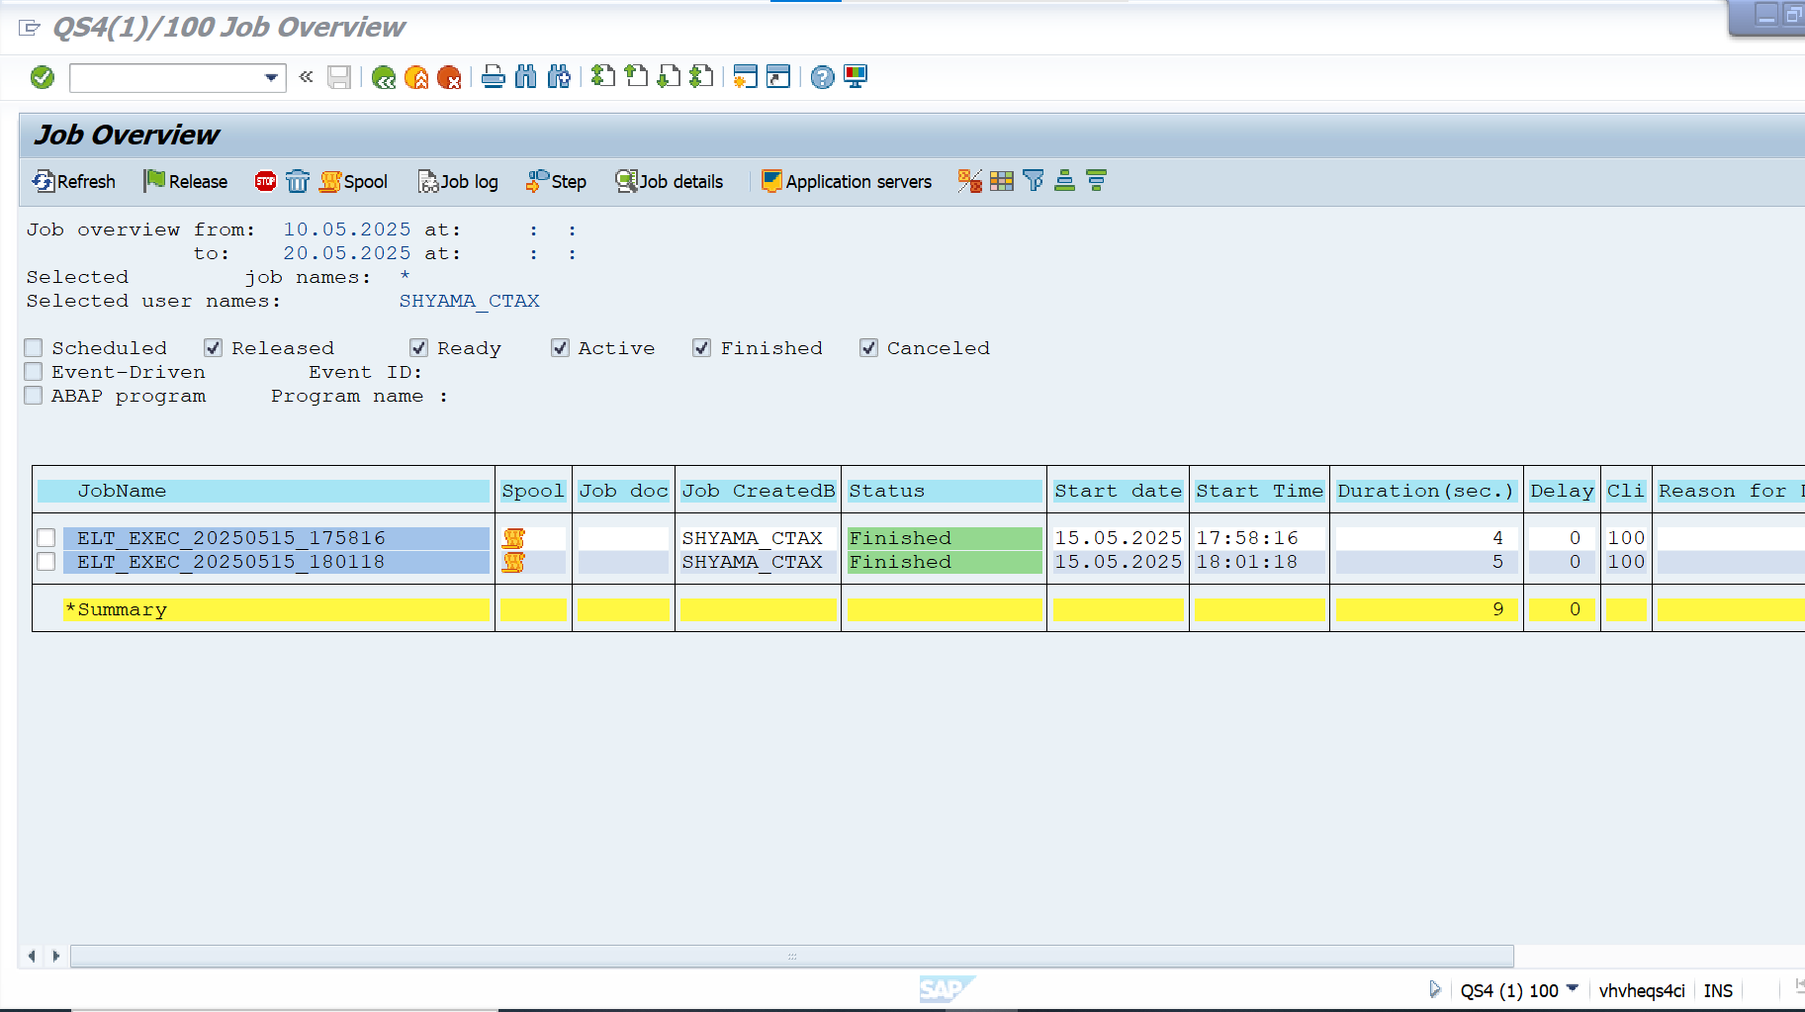

Job successfully finished with command id generation and data extraction from QS4 for the provided date.
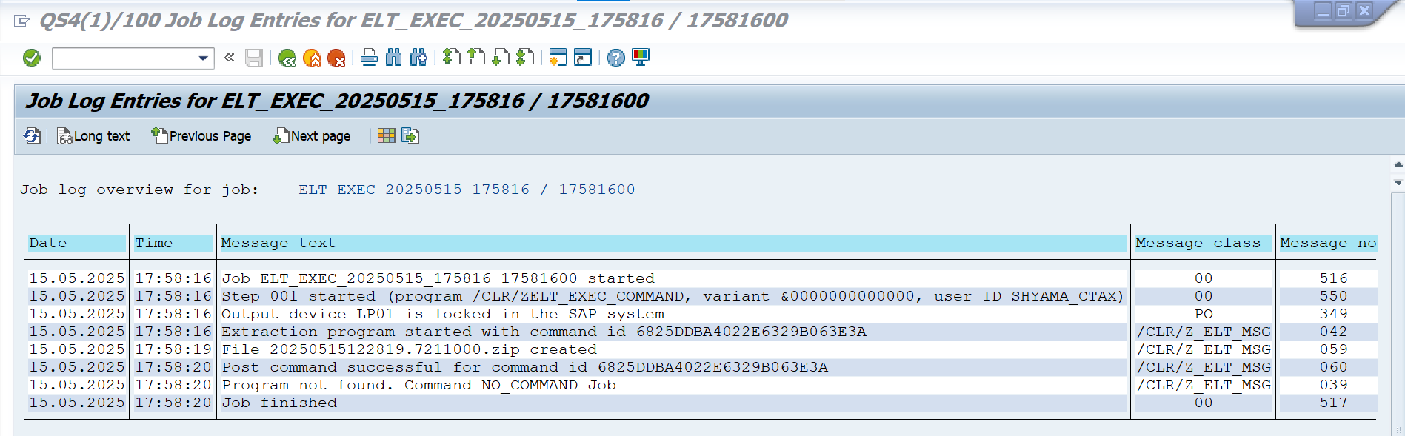
Result Successful: Pass

