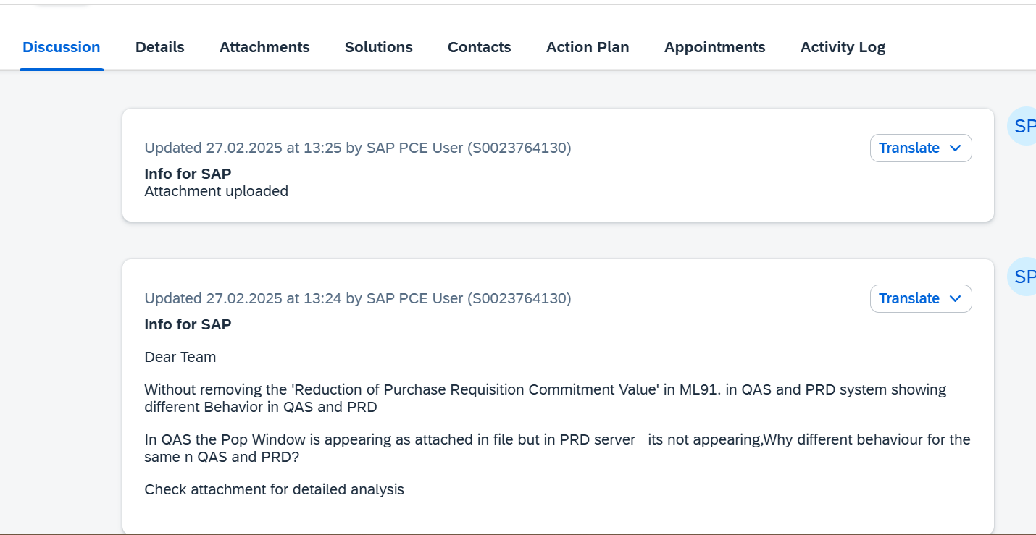

QAS

PR-4000002900
ME21N
This Pop window appearing in QAS
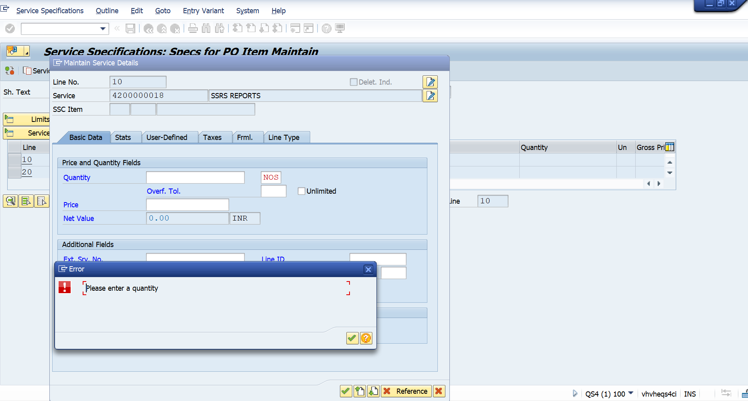
QAS-ML91 Check
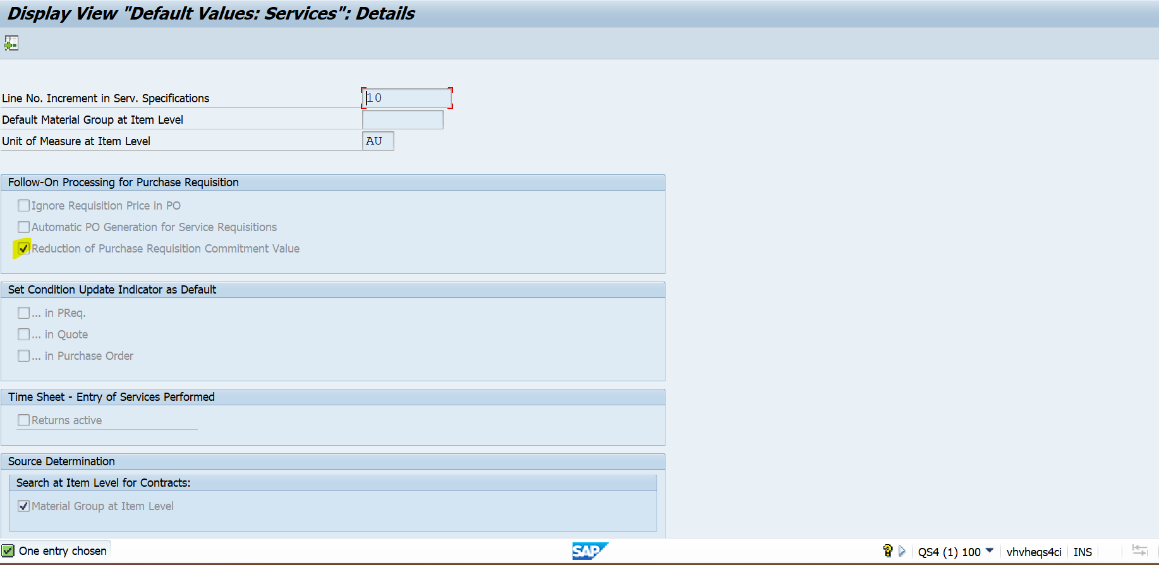

PRD
PR-4000004455

ME21N
POP UP window is not appearing
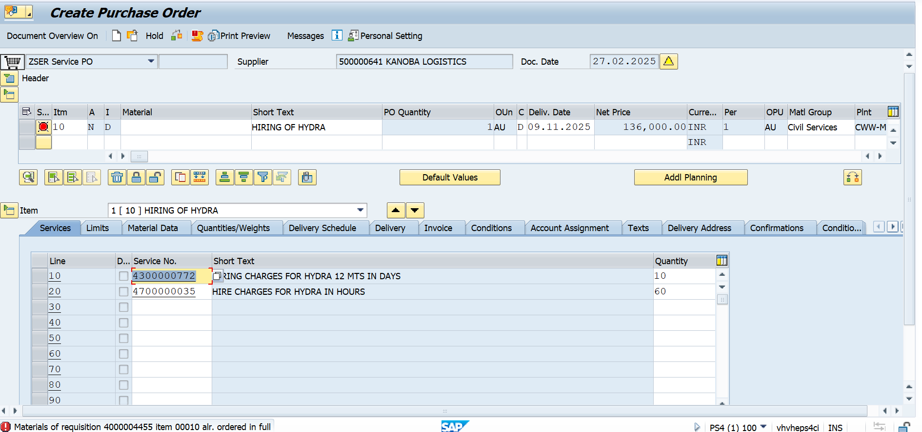
PRD
PRD-ML91 Check
