Master data specifications for GLs for posting to non leading ledgers

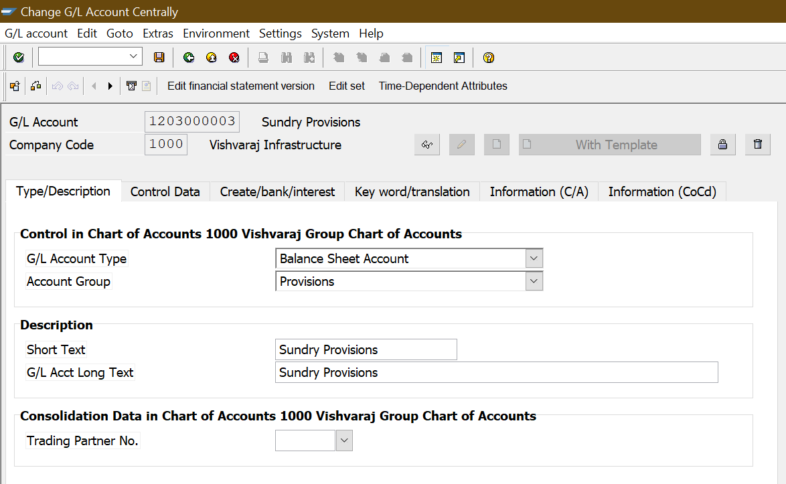

No change in this screen

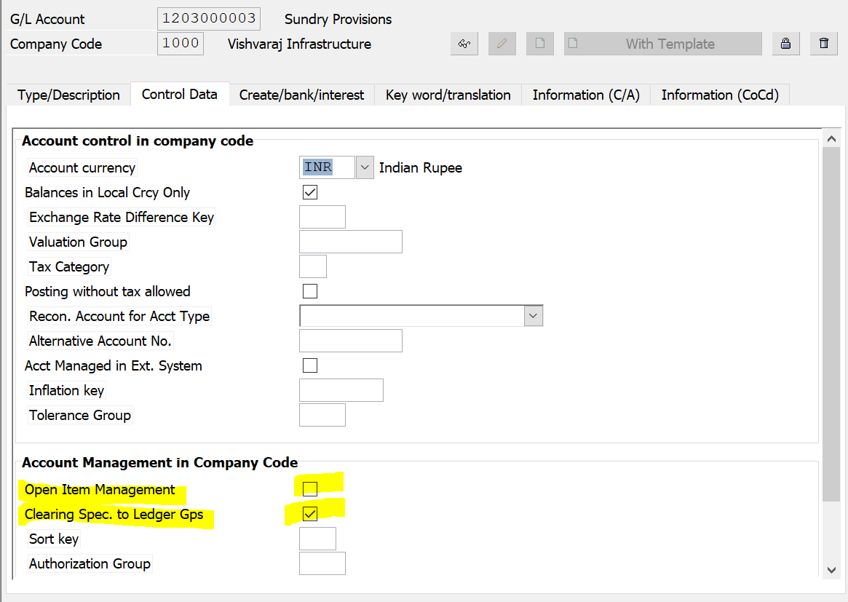

In the above screen, “Clearing specific to Ledger groups” should be ticked

Open Item Management should **not** be ticked.