NEW PO: 4000002385 CREATED

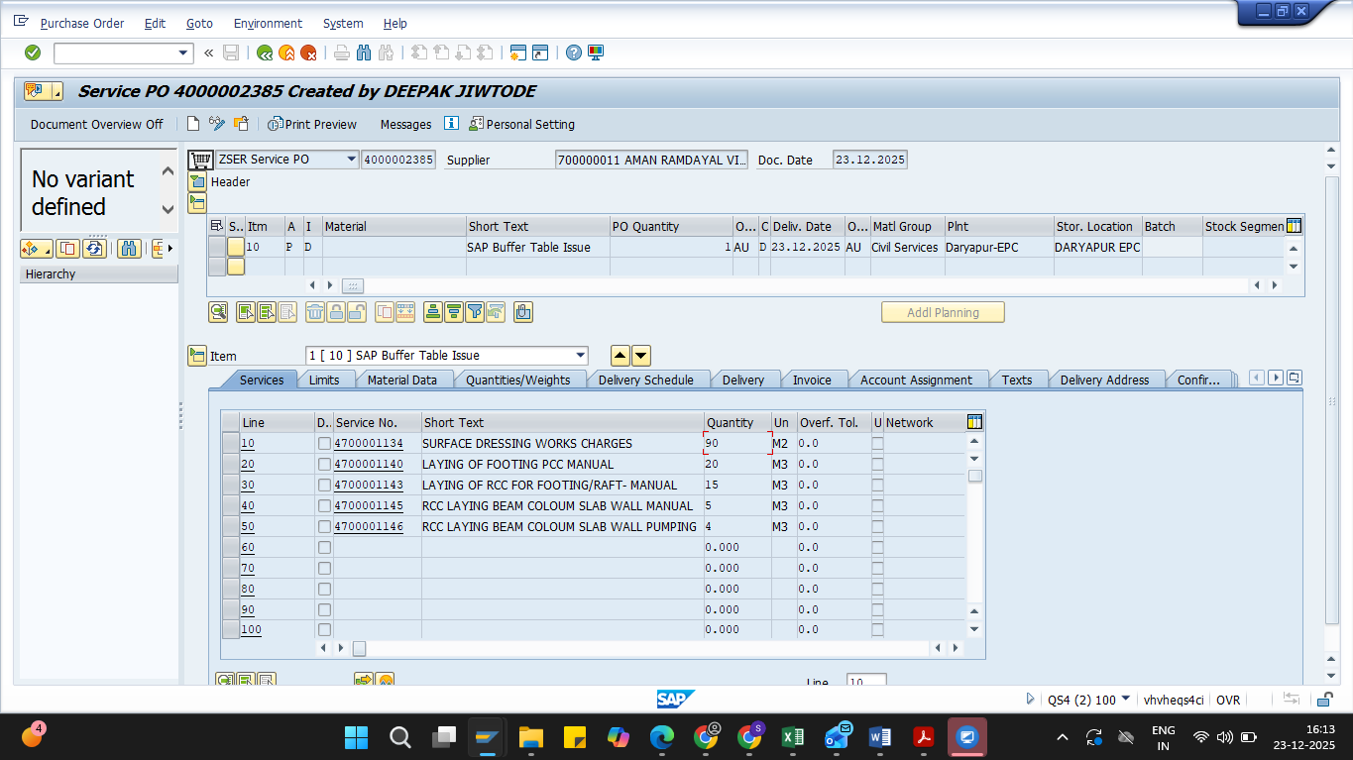
PARTIAL JMR DONE
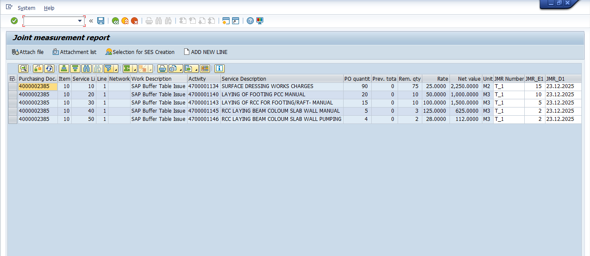

SES CREATED ML81N
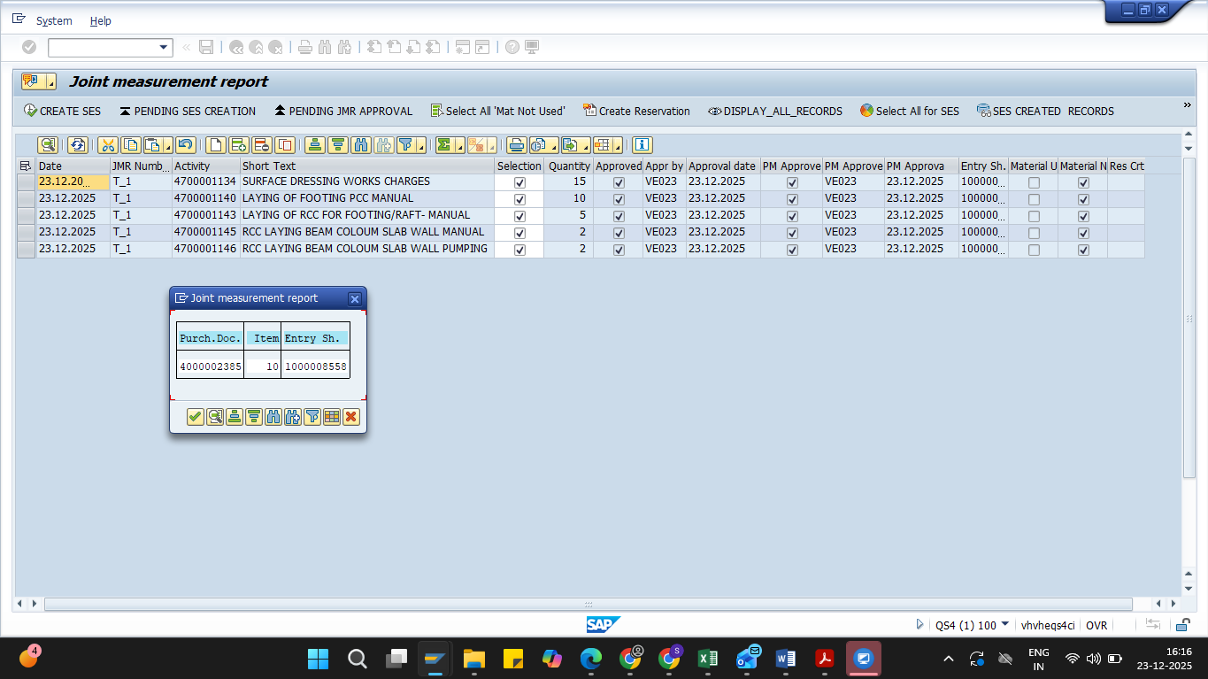

SES CREATED SUCCESSFULLY

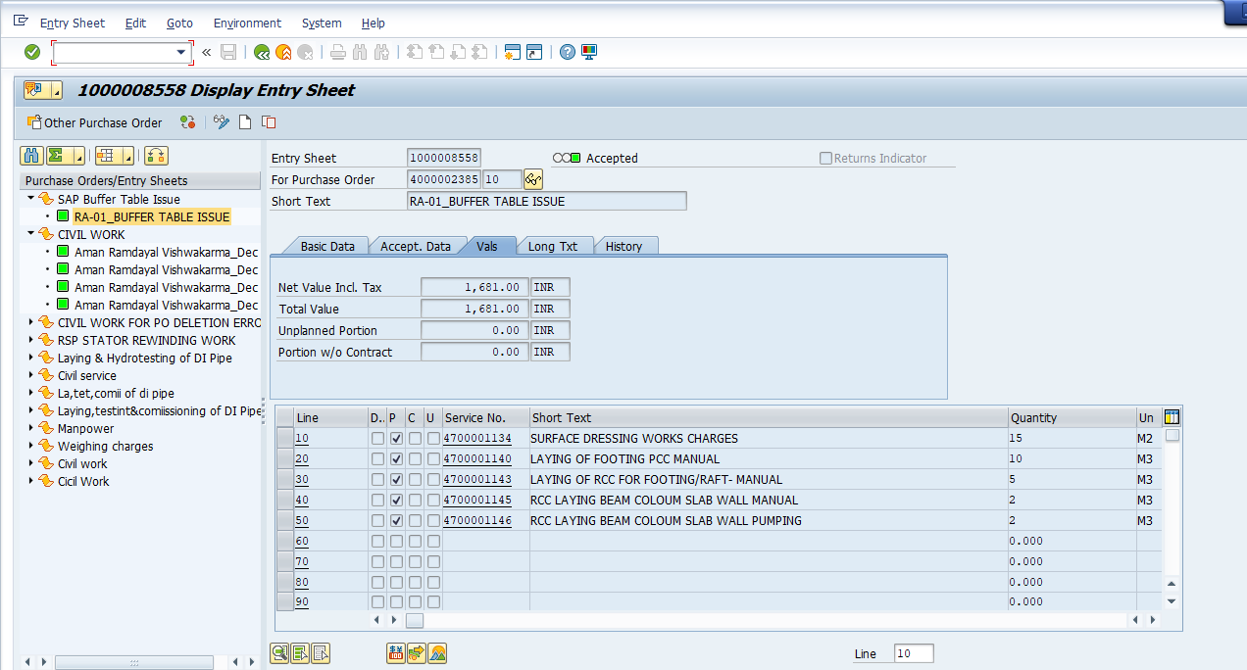
ALL ITEMS ARE SHOWING

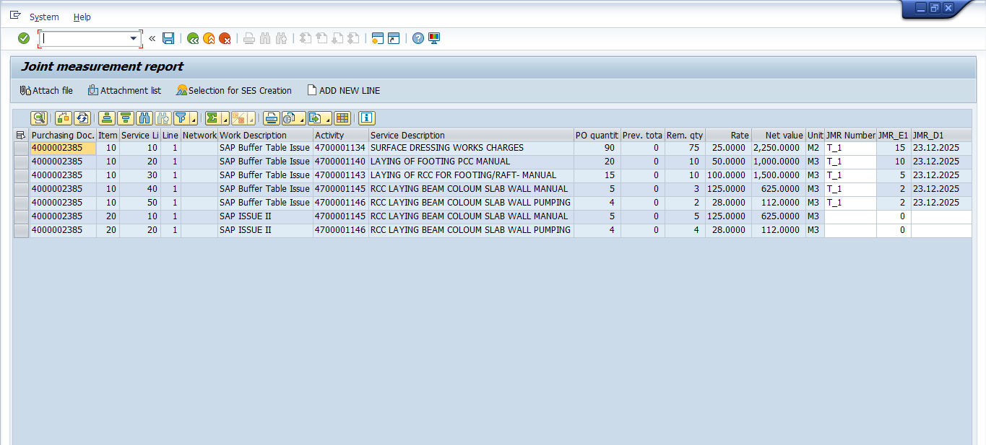
LINE ITEM 10 WAS DELETED, STILL IT IS SHOWING IN JMR INTERFACE ZMM049_N. CORRESPONDING TO WHICH WHILE CREATING JMR, “BUFFER TABLE ISSUE” STILL PROMPTING

