Unit testing

Ingestion job scheduled in QS4 server.
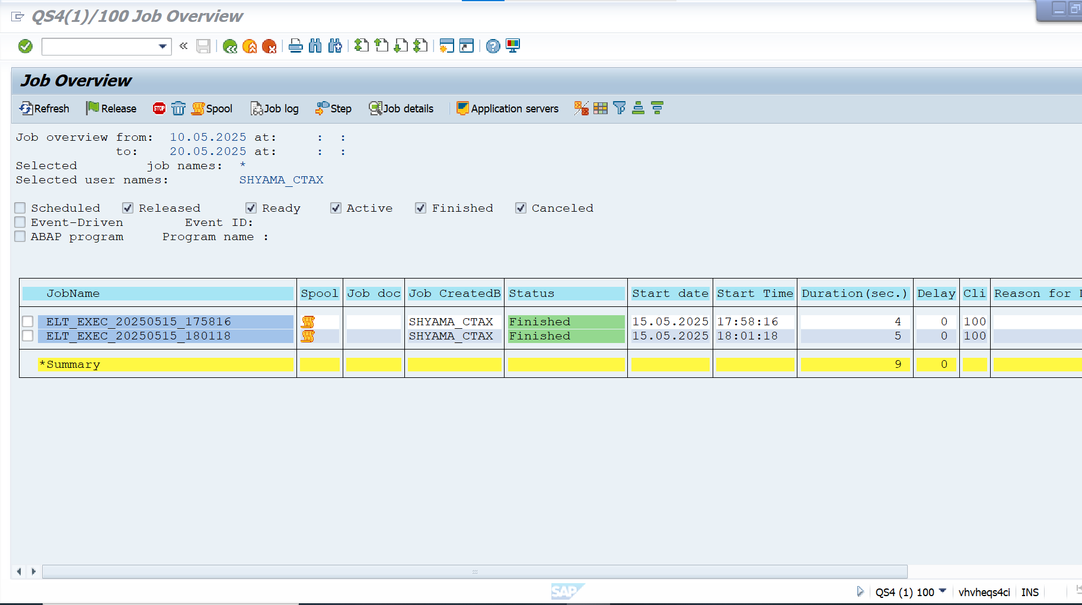

Job successfully finished with command id generation and data extraction from QS4 for the provided date.
