Vendor: 500000011: AKHIL GUPTA
QAS TESTING -PASS

TCODE – FB60

TDS SECTION 194D IN COMPANY CODE 1000 (OT-2%)

USER ID – VE026

- TYPE – OT

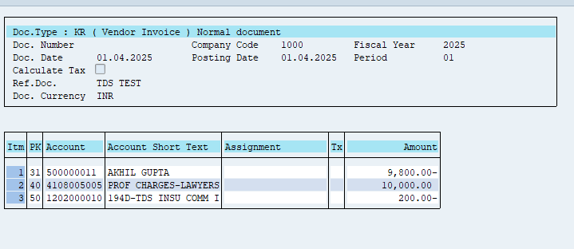

RESULT: TDS CORRECTLY CALCULATED @ 2%

- LOWER SIDE ROUNDING

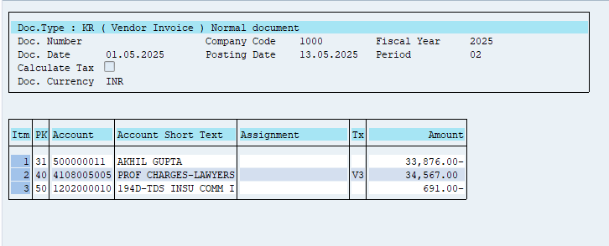

RESULT: SYSTEM IS DOING ROUNDING OFF PROPERLY

- HIGHER SIDE ROUNDING

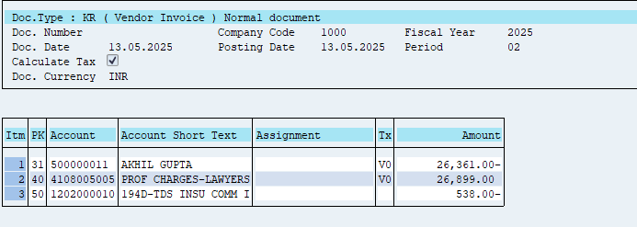

RESULT: SYSTEM IS DOING ROUNDING OFF PROPERLY

Vendor: 100000050: AIVA ENGINEERING PRIVATE LIMITED
QAS TESTING -PASS

TCODE – FB60

TDS SECTION 194D IN COMPANY CODE 1000 ( CO- 10%)

USER ID – VE026

- TYPE –CO

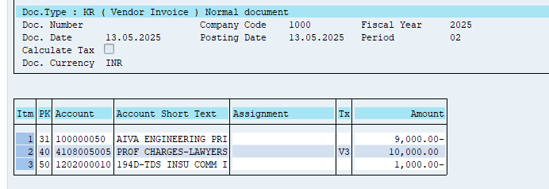
RESULT: TDS CORRECTLY CALCULATED @ 10%

- LOWER SIDE ROUNDING

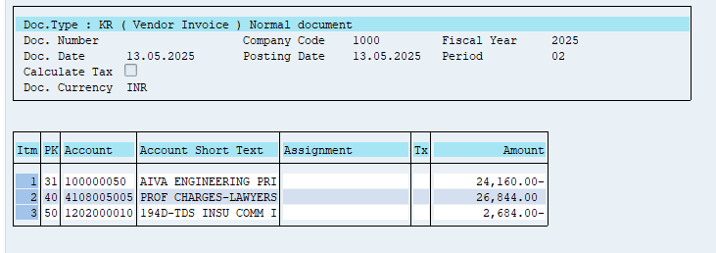

RESULT: SYSTEM IS DOING ROUNDING OFF PROPERLY

- HIGHER SIDE ROUNDING

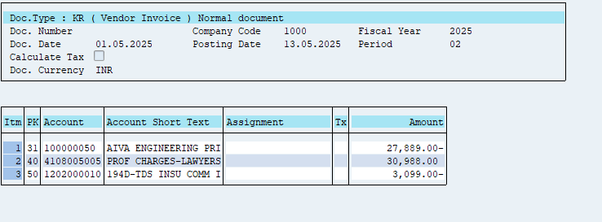

RESULT: SYSTEM IS DOING ROUNDING OFF PROPERLY

