# Test Script ID:

|  |  |  |  |
| --- | --- | --- | --- |
| **SCRIPT TITLE**: | PO Release Strategy | **TESTER NAME:** | Rushikesh Dhote |
| **DESCRIPTION**: | PROJECT Material/service Release Strategy |  |  |

**TEST DATA**

|  |  |  |  |
| --- | --- | --- | --- |
| **DATA OBJECT** | **VALUE/CODE** | **DESCRIPTION** | **COMMENTS AND NOTES** |
|  |  |  |  |
|  |  |  |  |
|  |  |  |  |
|  |  |  |  |

| Step # | BUSINESS PROCESS STEPS /  BPP/PDD NUMBER | T- CODE | INPUT DATA / SPECIAL INFORMATION | EXPECTED RESULT | OUTPUT DATA / ACTUAL RESULT | PASS/  FAIL |
| --- | --- | --- | --- | --- | --- | --- |
| 1 | Create PO | ME21N/ME29N | Select Document type ZPM/ZPS/ZMAT/ZIMP/ZCOM/ZSER/ZEME | User should be able to create PO | User should able to create PO and release strategy will triggered accordingly. | Pass |

**TRANSACTIONAL STEPS**

In Case Project Material 0-2 Lakh

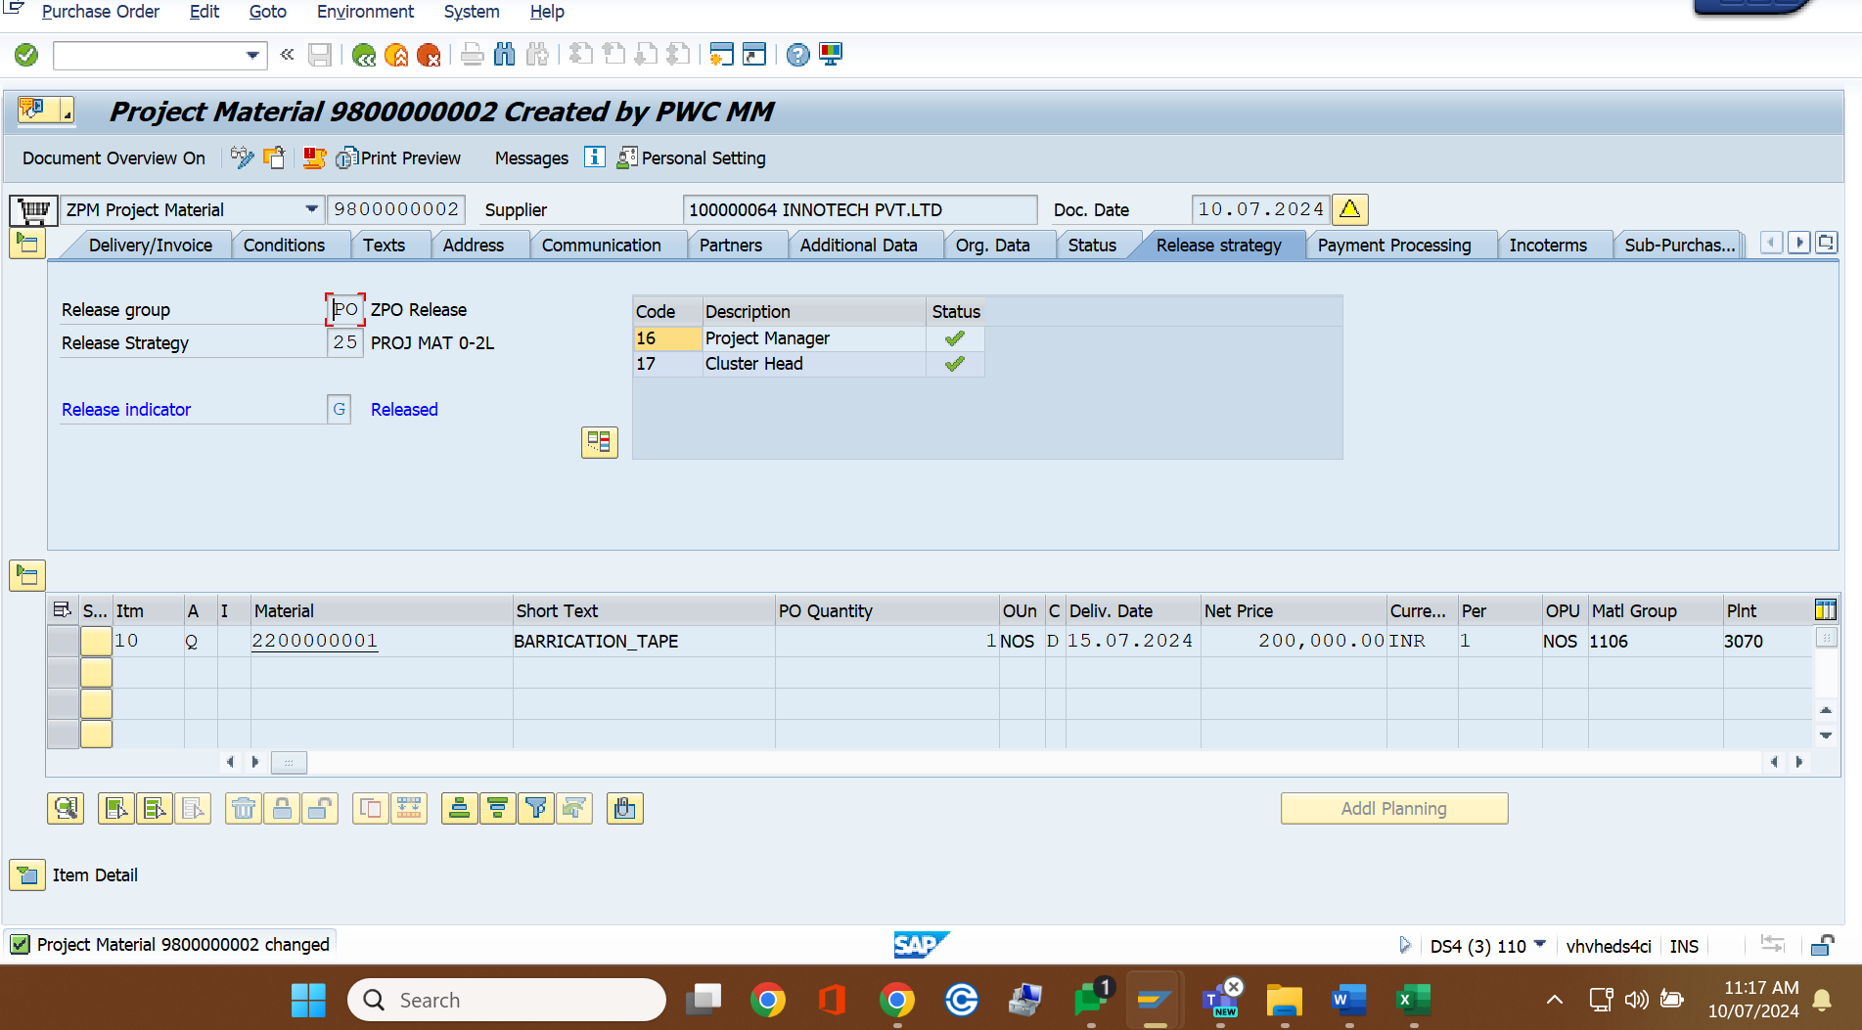

In Case Project Material 2-10 Lakh

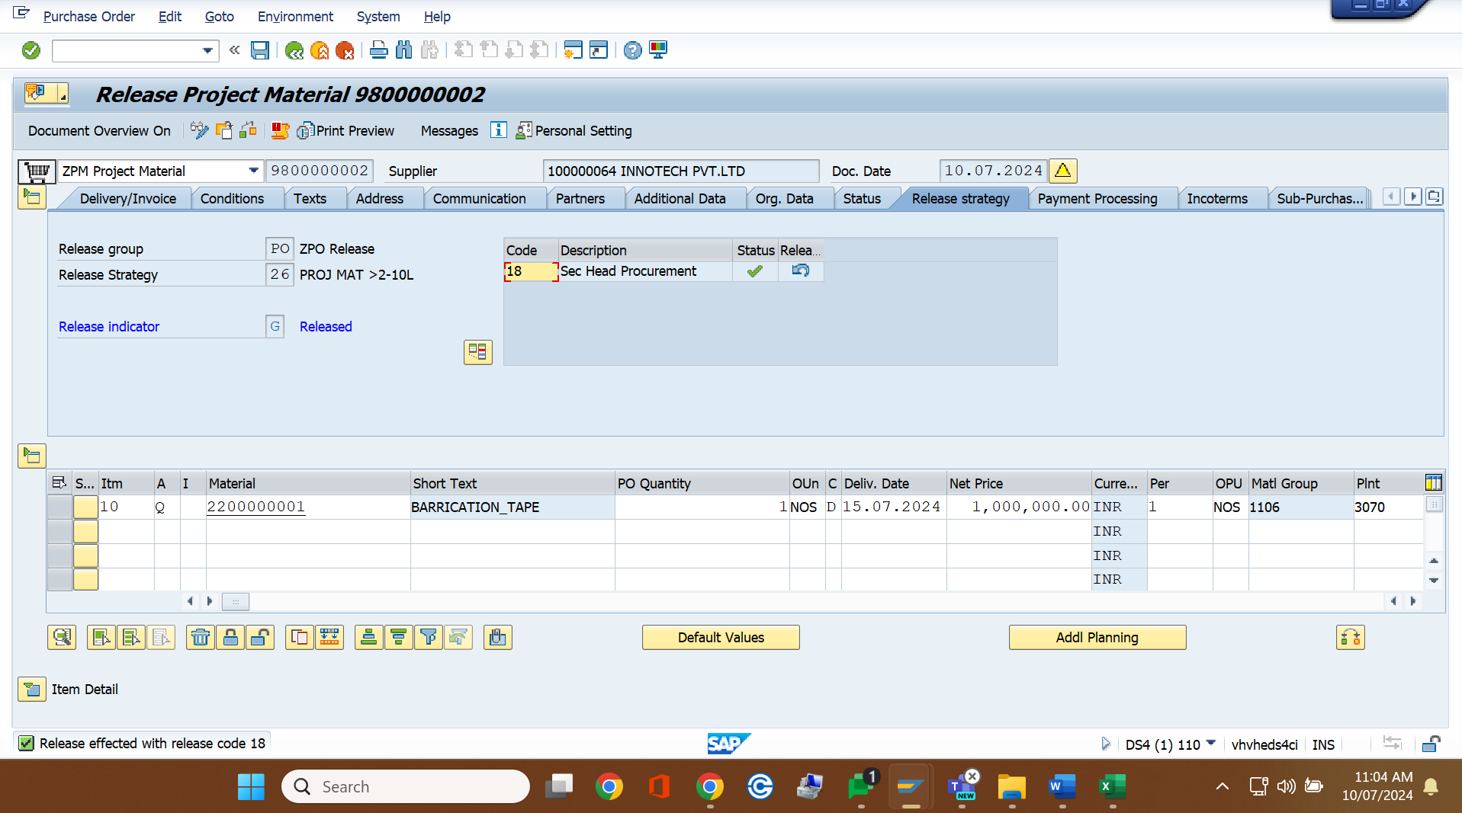

In Case Project Material 10-100 Lakh

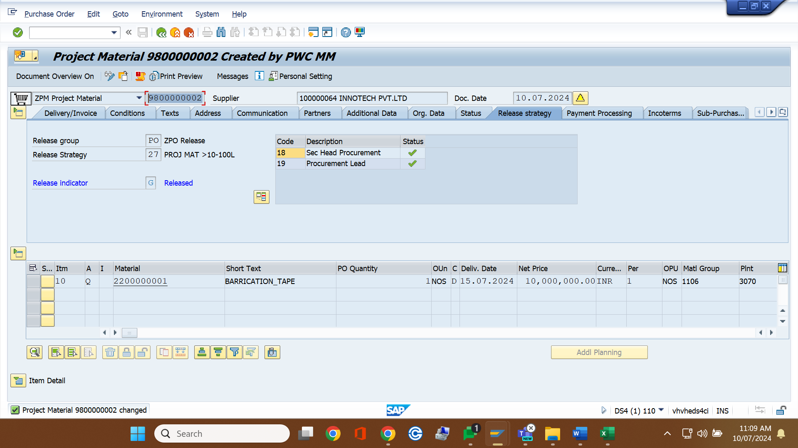

In Case Project Material>100 Lakh

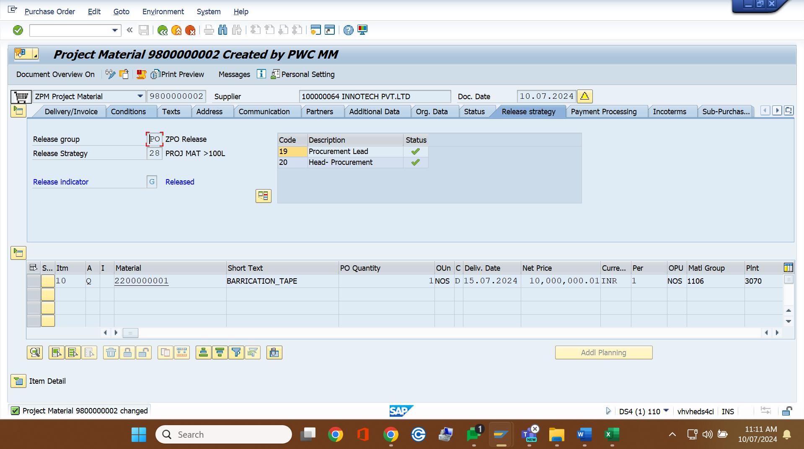

In Case Project Service 0-5 Lakh

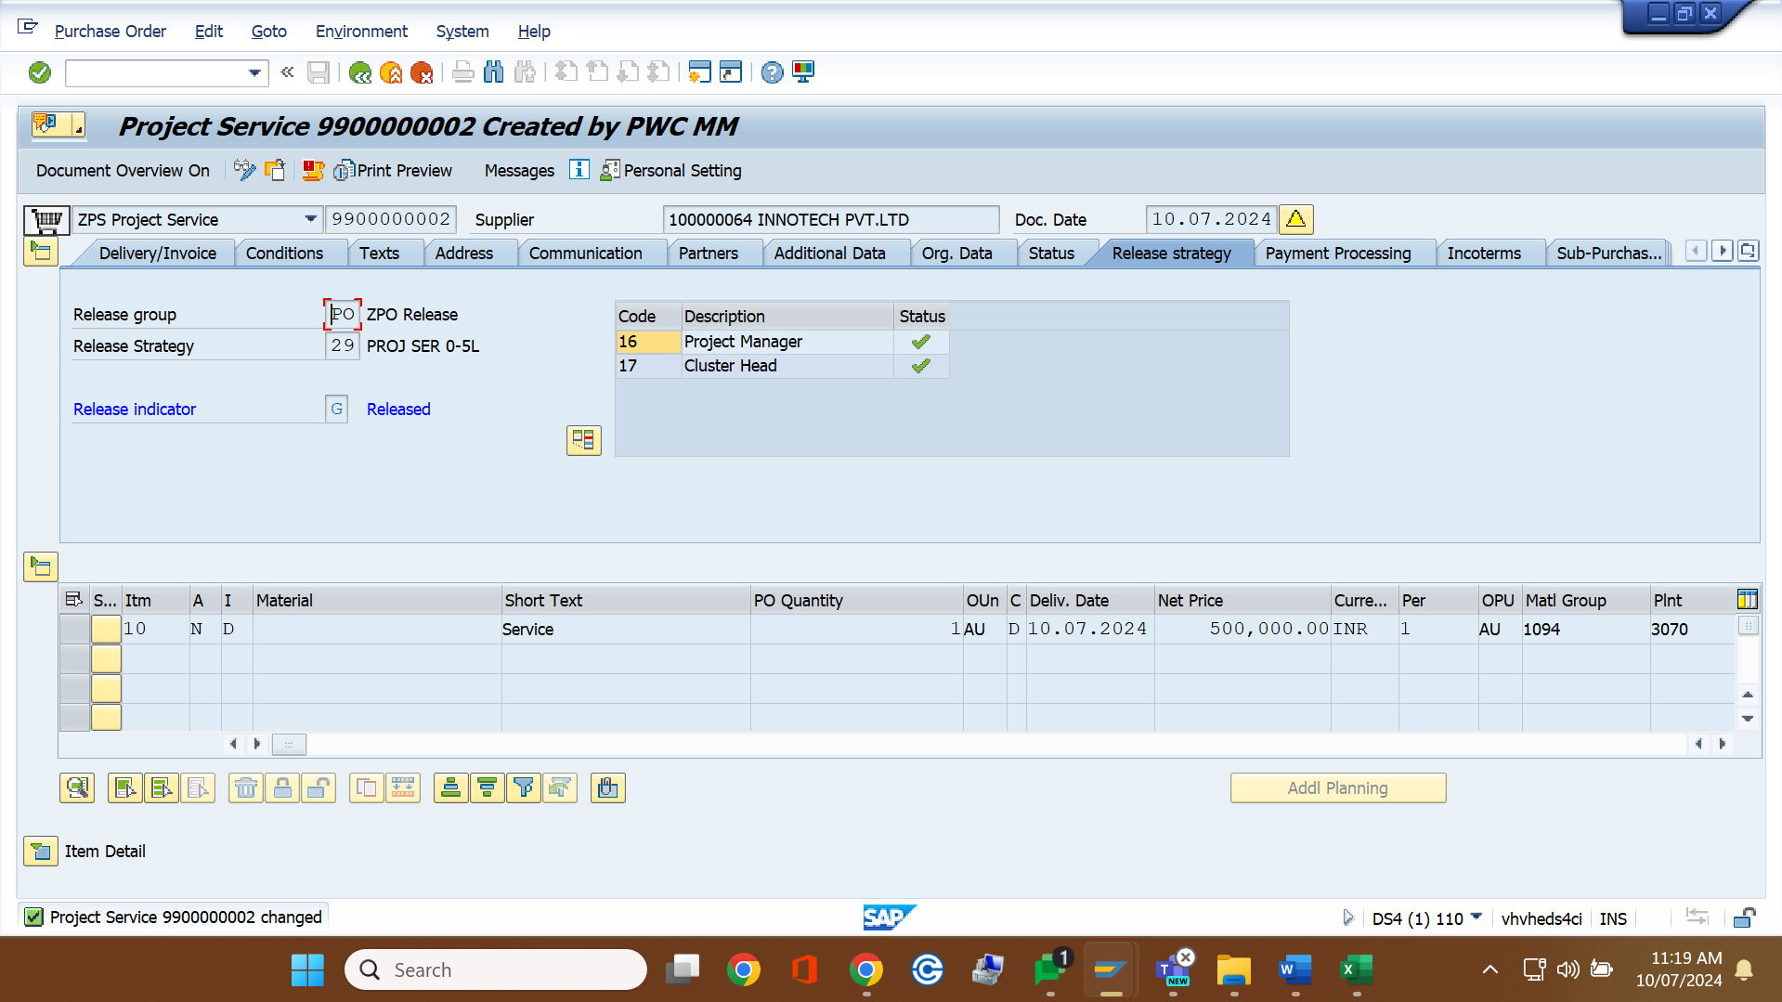

In Case Project Service 5-10 Lakh

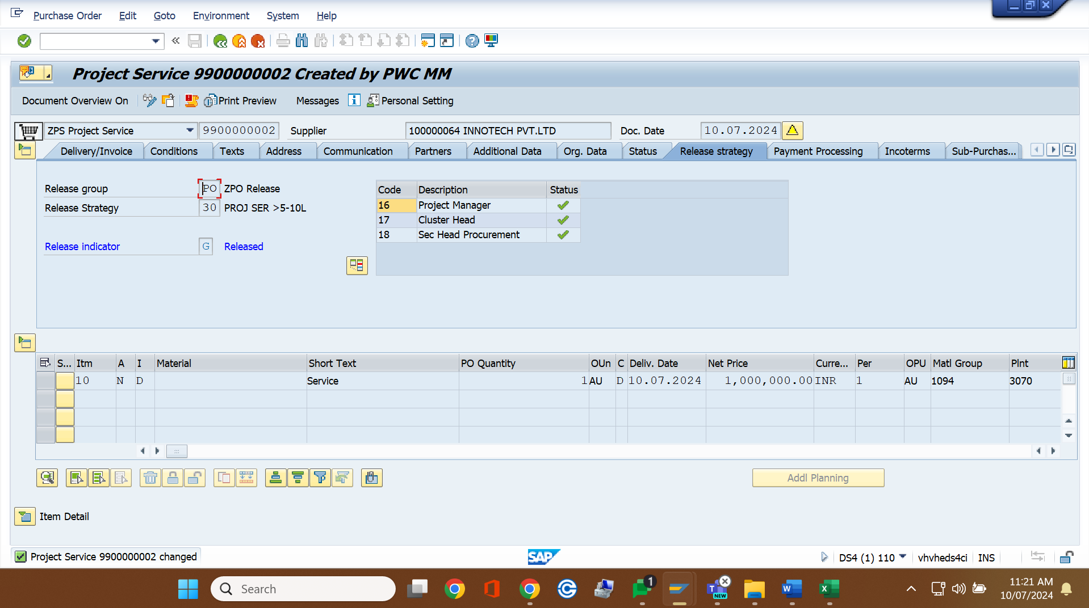

In Case Project Service 10-100 Lakh

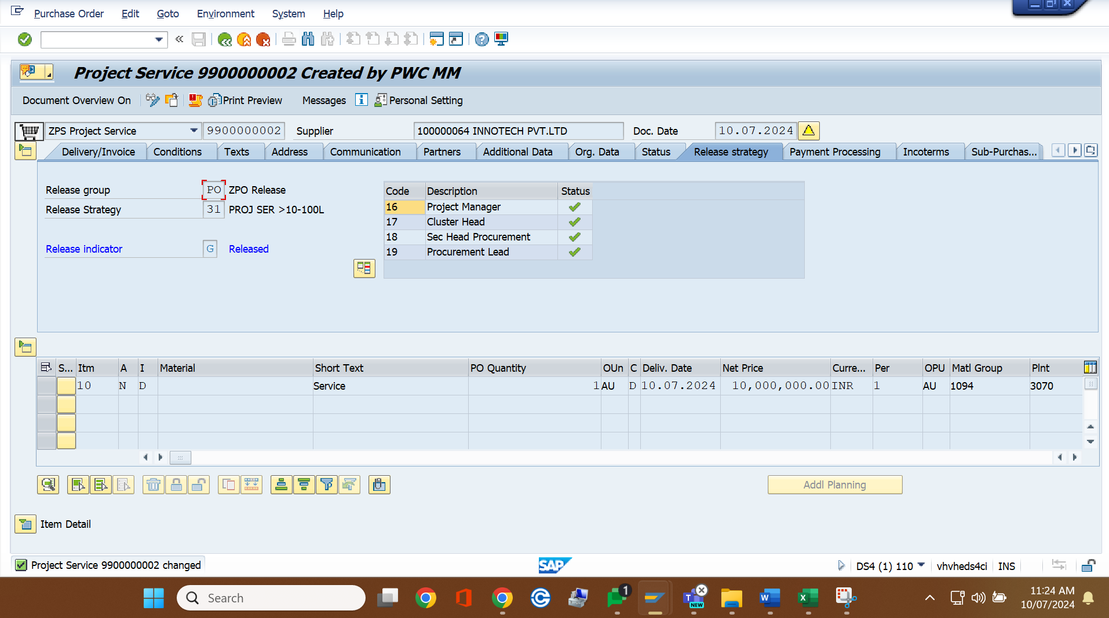

I

In Case Project Service >100 Lakh

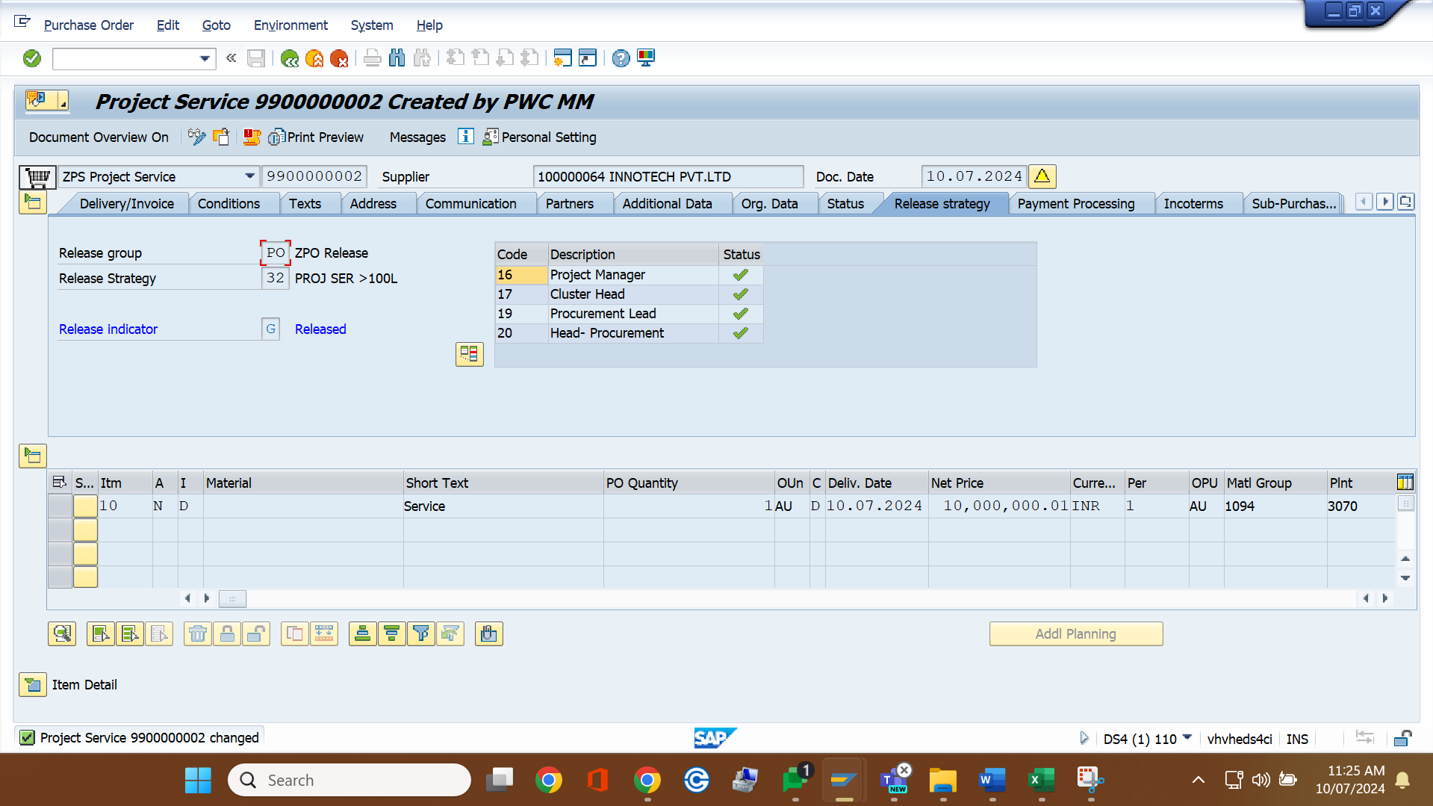

In Case Material PO 0-10 Lakh

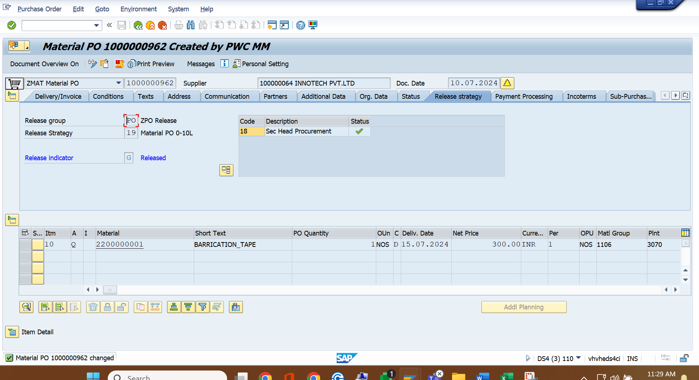

In Case Material PO 10-100 Lakh

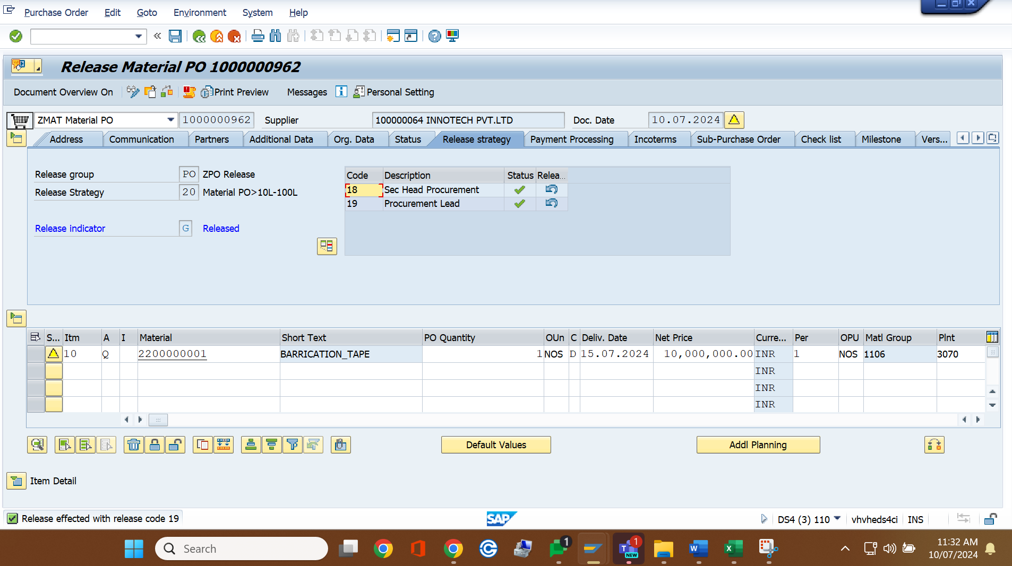

In Case Material PO >100 Lakh

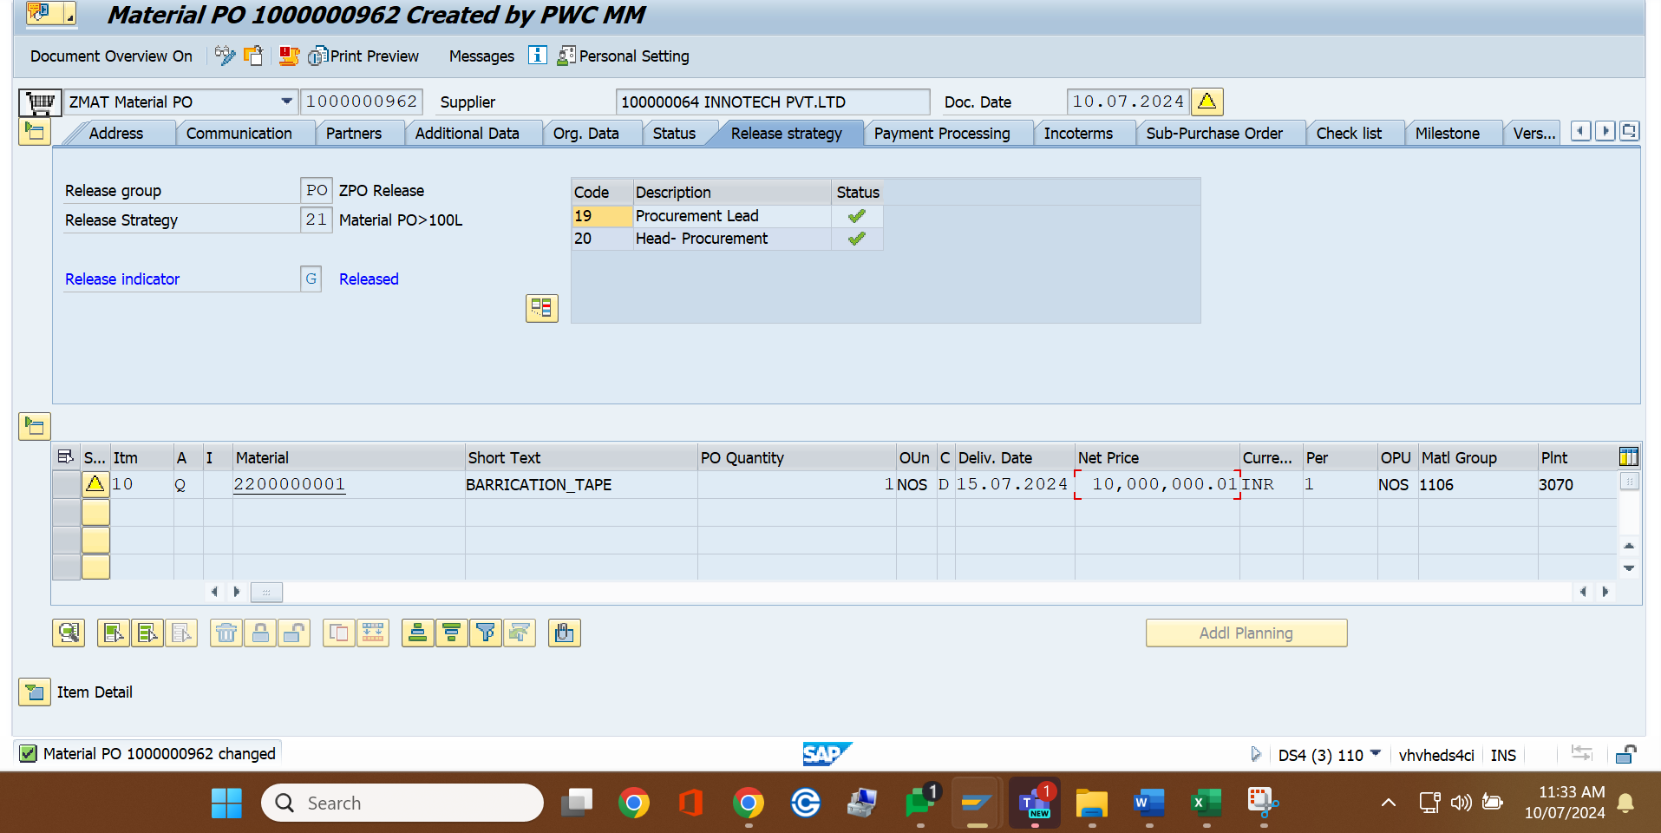

In Case Service PO 0-10 Lakh

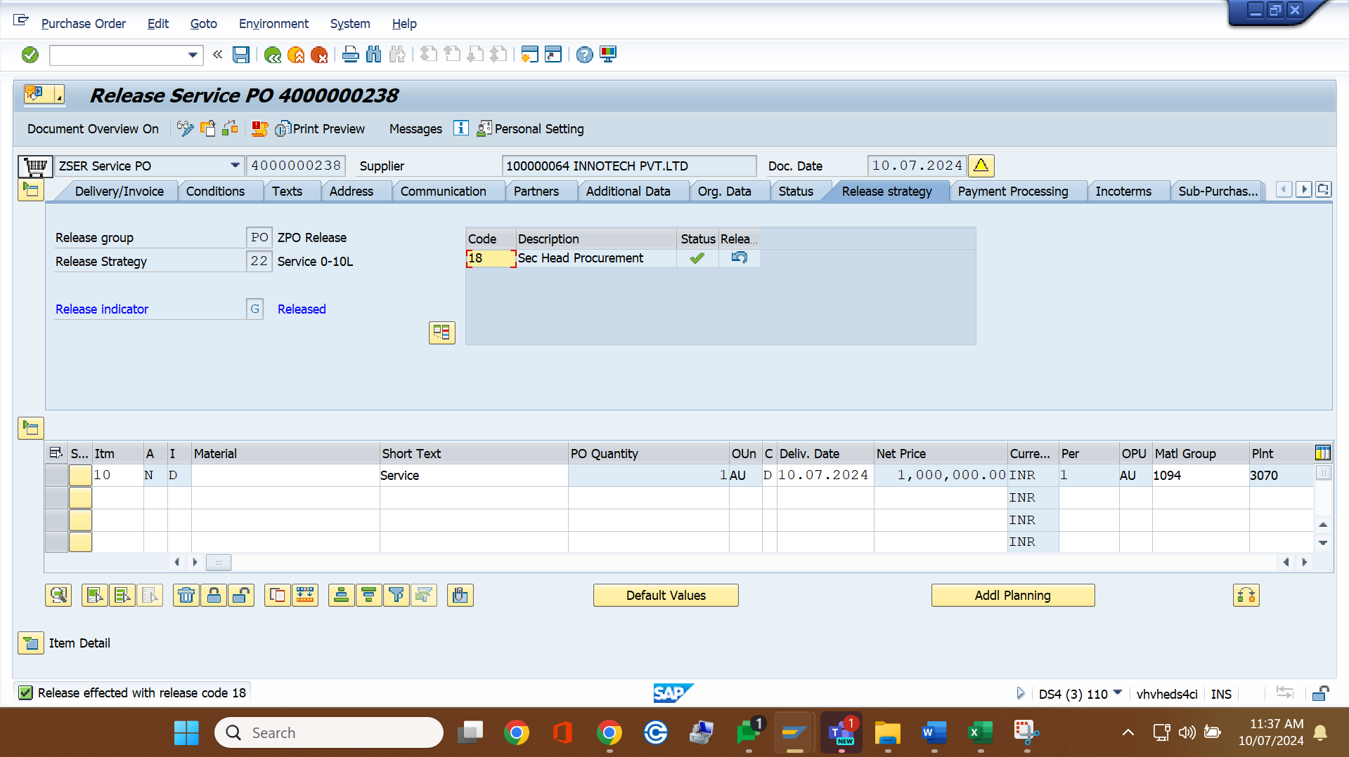

In Case Service PO 10-100 Lakh

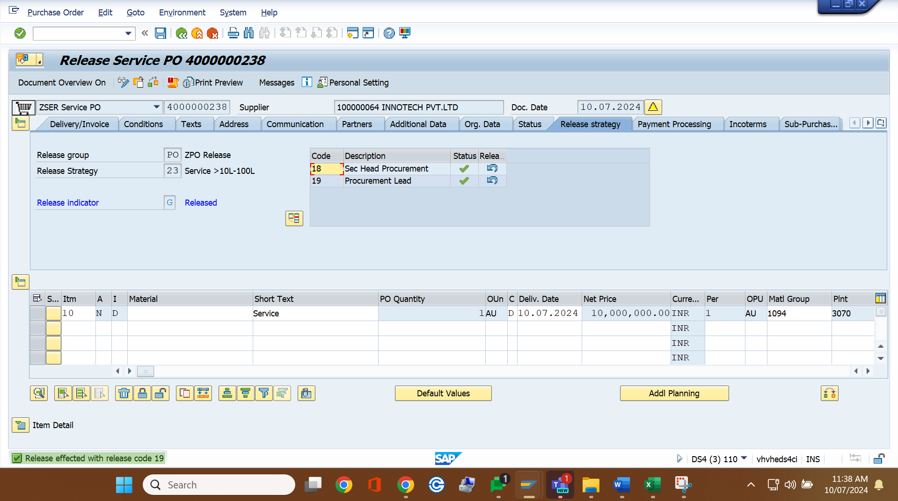

In Case Service PO >100 Lakh

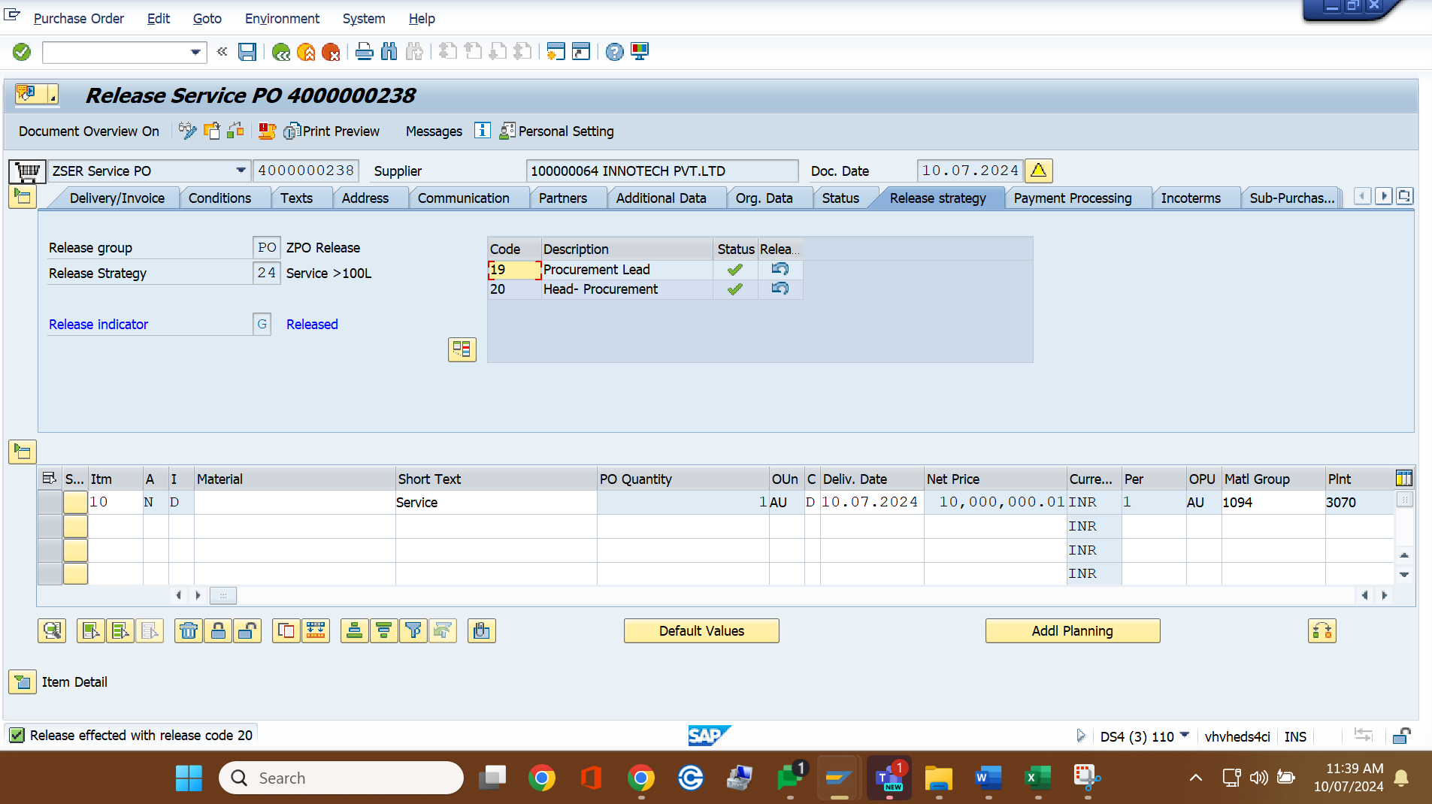

.

Release PO T-code ME29N

**Test Execution Remarks:** Test execution completed successfully.

# Tester Signature: _________________________ Test Execution Date: