ME2J

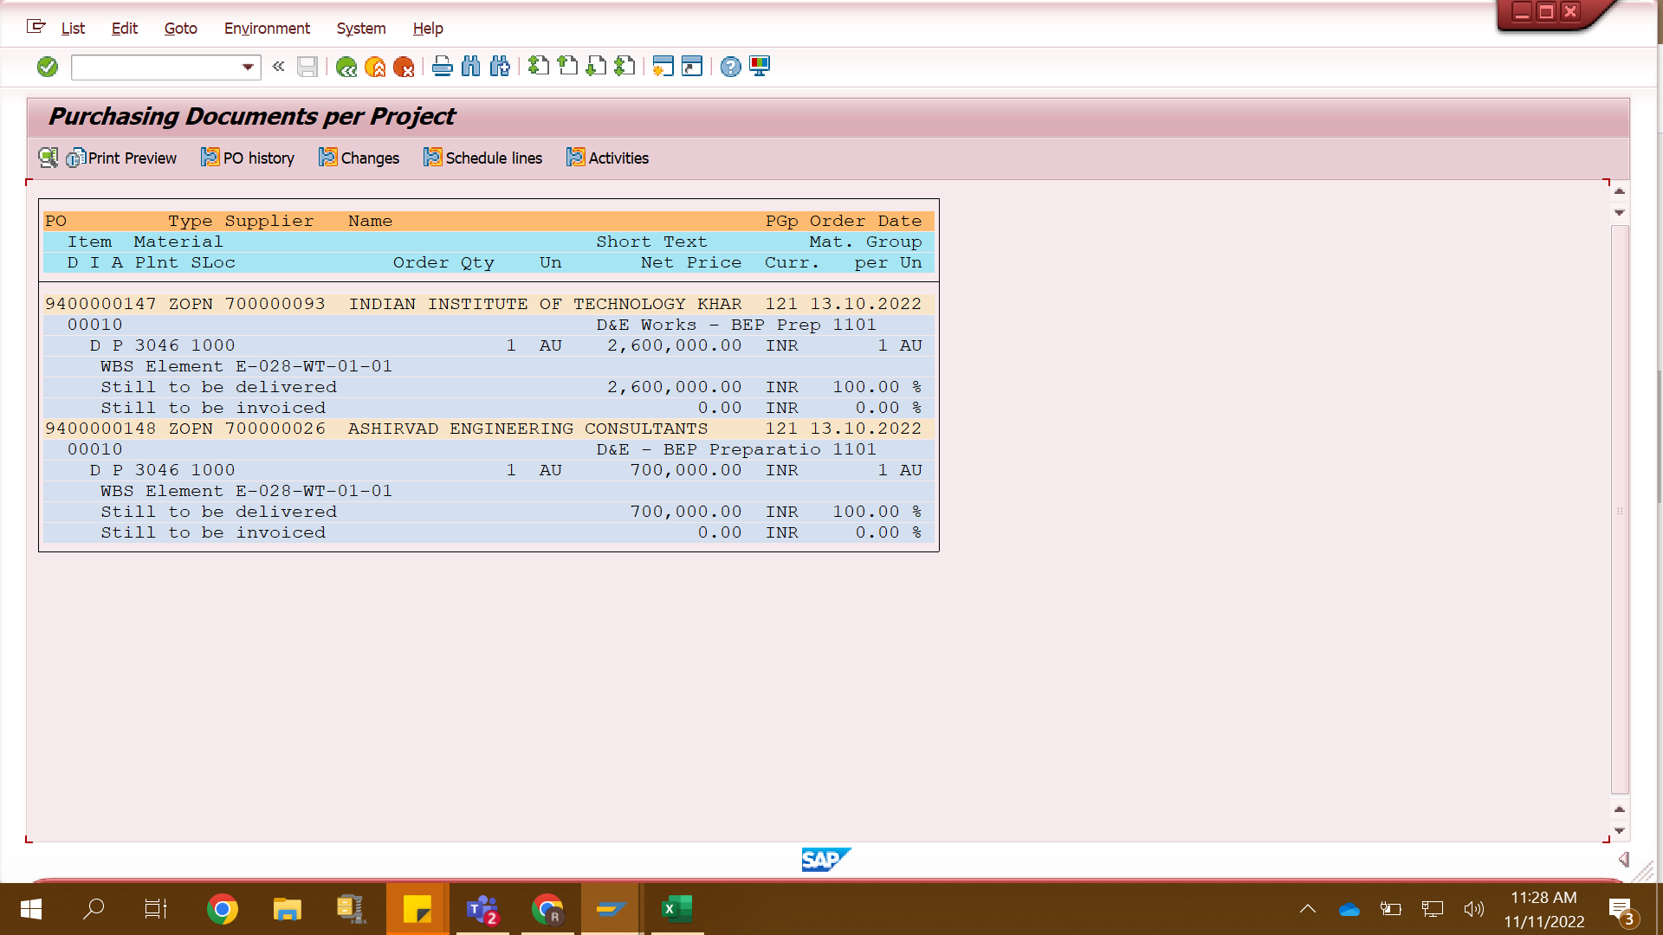

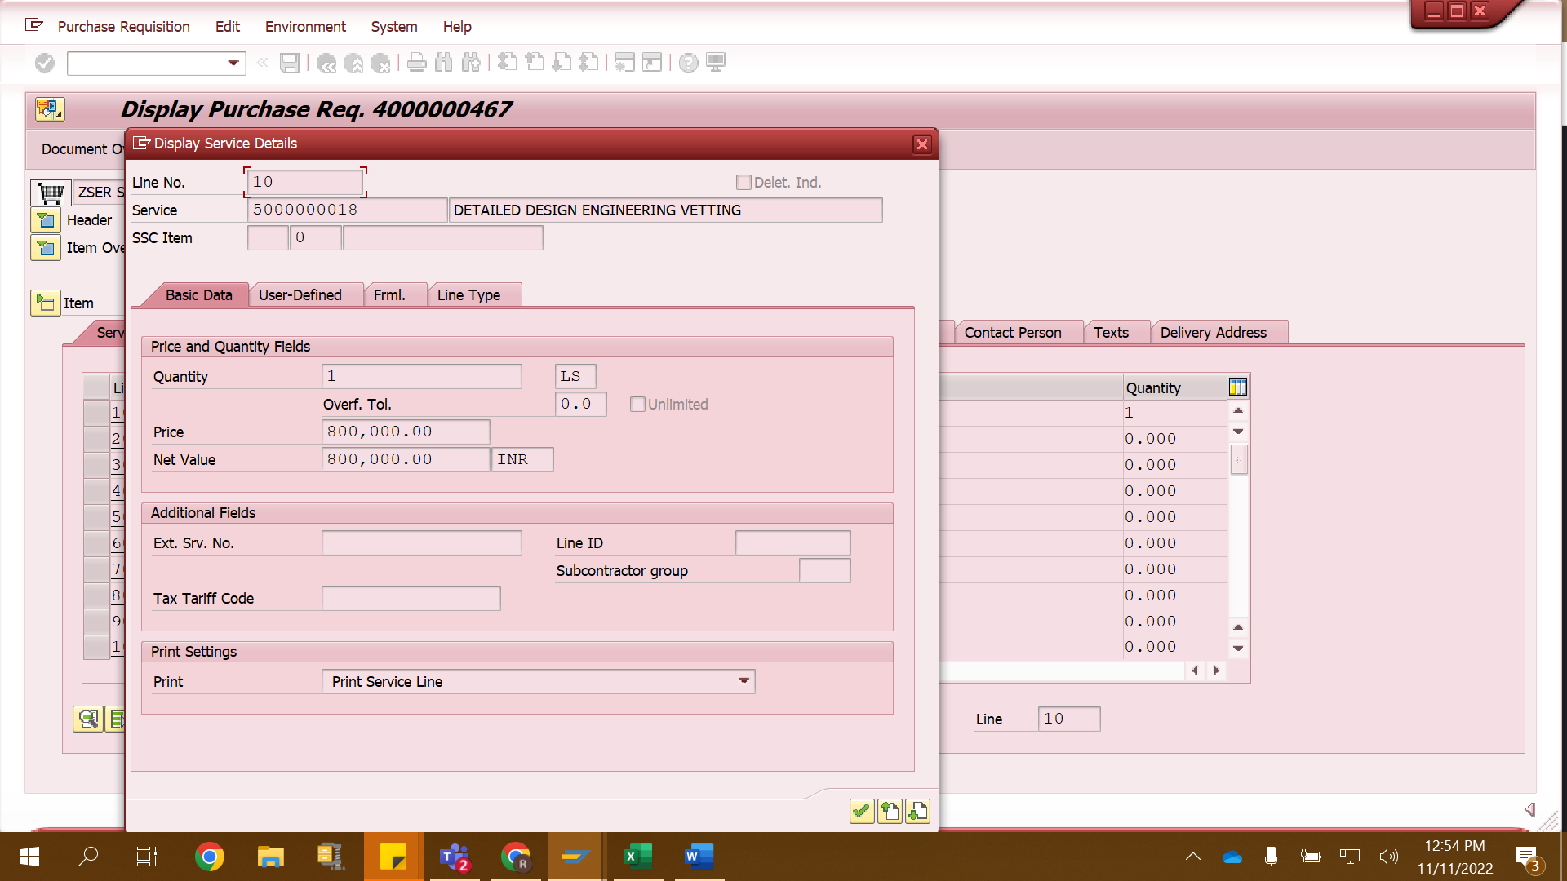

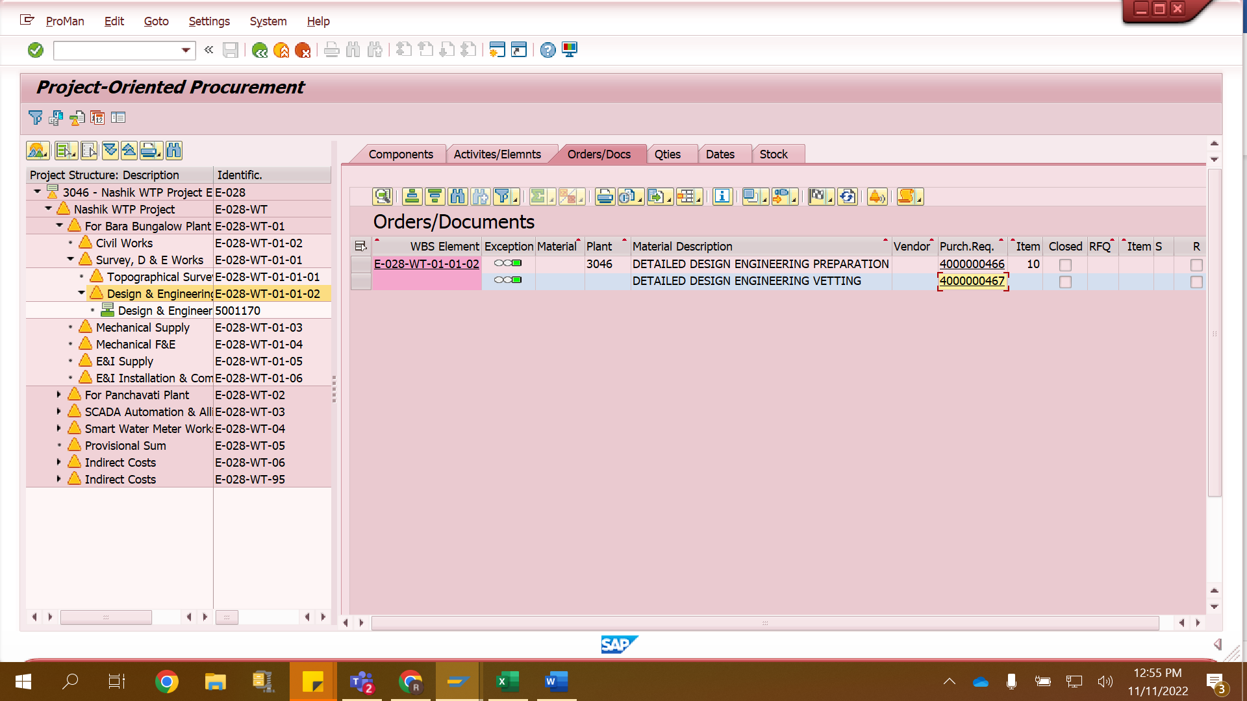

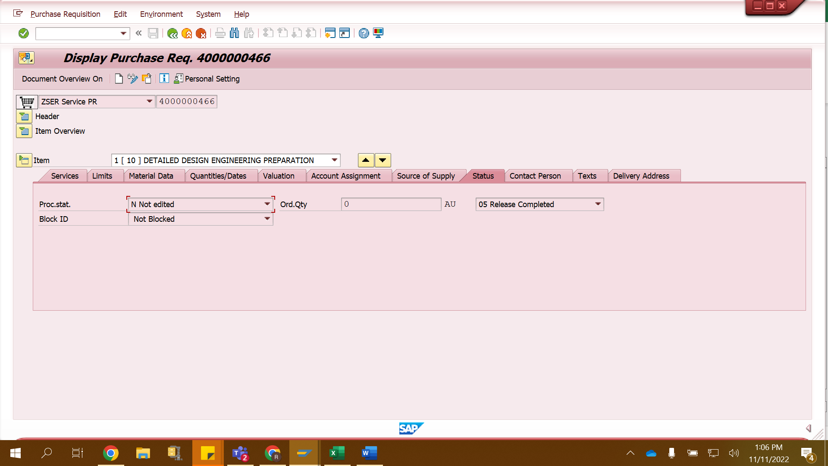

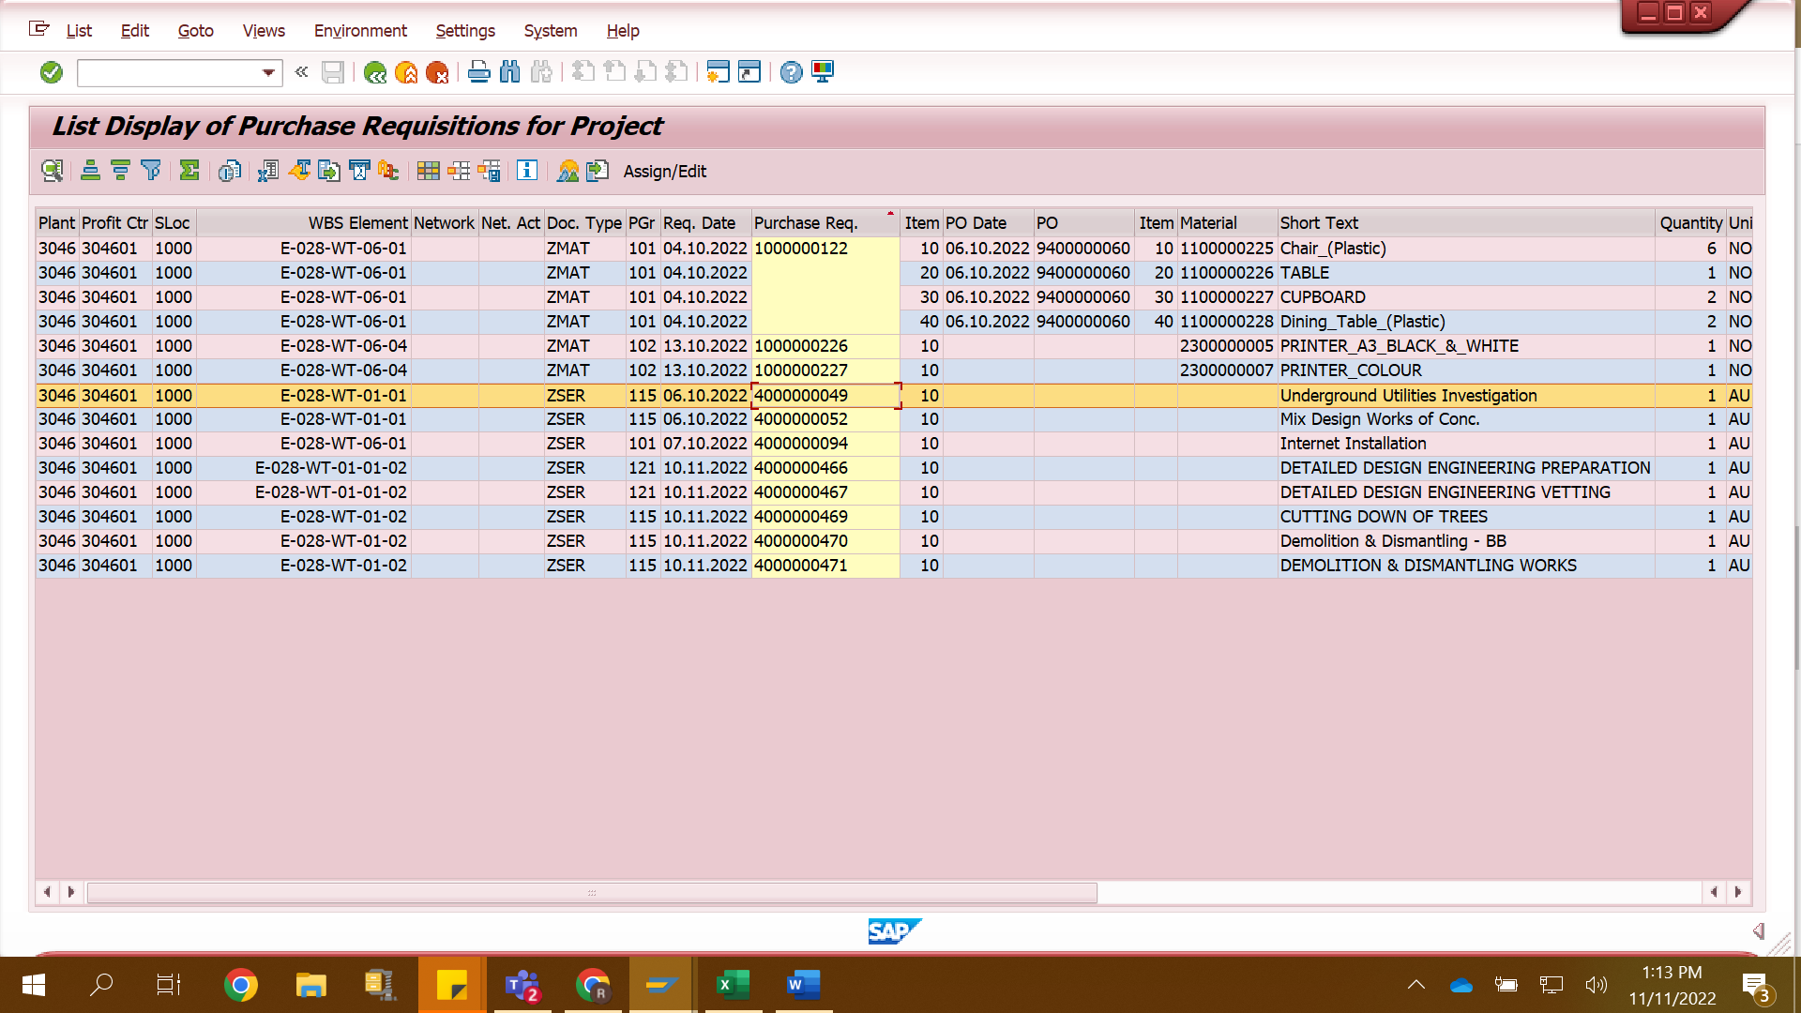

|  |  |  |  |
| --- | --- | --- | --- |
| E-028-WT-01-01 | **4000000095** | 2,600,000.00 | **9400000147** |
|  | **4000000096** | 700,000.00 | 9400000148 |
|  |  |  |  |
| E-028-WT-01-01 | 4000000049 | 314,440.80 |  |
|  | 4000000052 | 112,500.00 |  |
|  |  |  |  |
| E-028-WT-01-01-02 | 4000000466 | 2,600,000.00 |  |
|  | 4000000467 | 800,000.00 |  |
|  |  |  |  |
|  |  | **7,126,940.80** |  |
| E-028-WT-01-01 | Avlb | 132,956 |  |
|  | Value of PR | 165,000.00 |  |
|  | **Thus Budget warning** | |  |
|  |  |  |  |